Water-based rosin emulsion
Description | WPS-1005 is a product with rosin ester as raw material, light color, high softening point and excellent aging resistance. It is suitable for general-purpose pressure-sensitive adhesive system and can significantly improve the adhesive performance of adhesive products.
Type | Water-based rosin emulsion
Key Features | - Non-toxic, eco friendly  - Using a unique surfactant, it significantly improves the initial tack, peel strength and tack of the adhesive after addition.  - Small particle size, good mechanical stability, excellent flowability  - Low surface tension, low foam, coating uniformity, no "fish eye" Online  - Good compatibility: can significantly improve the adhesive products and achieve the best balance point
Typical Properties | Model WPS-1005A WPS-1005B WPS-1005C WPS-1005D WPS-1005E WPS-1005F  Solid Content 49-51% 49-51% 54-56% 49-51% 54-56% 54-56%  PH Value 6-8 6-8 6-8 7-9 7-9 7-9  Softening point 68-78 65-75 65-75 65-75 75-85 75-85  Brookfield viscosity 600-1200 600-1200 100-600 600-1200 ≤300 300-1000  Particle size(Nm) ≤270nm ≤270nm ≤250nm ≤270nm ≤600nm ≤600nm
APPLICATION | - Water based paints  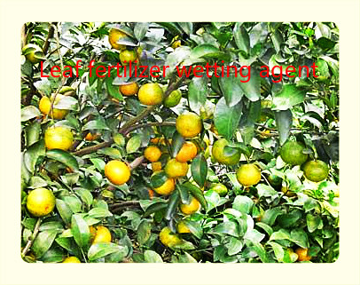  - Waterbased adhesive  - Natural and synthetic rubber emulsion  - Interior and exterior building putty and other aspects
Storage and Handling | - Available in 200 kg/ barrel or 1000kg/barrel (IBC)  - Store products in tightly closed original containers at 5-35℃  - Shelf life: 9-12 months from delivery date  - According to non-dangerous goods transport

